**Project Development Phase**

**Model Performance Test**

|  |  |
| --- | --- |
| Date | 16 NOvember 2022 |
| Team ID | Team-592275 |
| Project Name | Gilded Emotions: Unearthing Market Sentiments In Gold News |
| Maximum Marks | 10 Marks |

**Model Performance Testing:**

Project team shall fill the following information in model performance testing template.

|  |  |  |  |
| --- | --- | --- | --- |
| **S.No.** | **Parameter** | **Values** | **Screenshot** |
|  | Metrics | **Regression Model:** SVM Training Accuracy: 0.9679455239993356  SVM Validation Accuracy: 0.9197985277024409  SVM Regression Metrics:  SVM MAE: 0.13405656722200698  SVM MSE: 0.24176675707090275  SVM RMSE: 0.49169783106182474  SVM R2 Score: 0.7441089467109723  **Classification Model:** Confusion Matrix - , Accuray Score- & Classification Report – | [SC-1] in the next page  [SC-2] in the next page |
|  | Tune the Model | Hyperparameter Tuning -  Validation Method - |  |

|  |  |  |  |
| --- | --- | --- | --- |
| **S.No.** | **Parameter** | **Values** | **Screenshot** |
|  | Metrics | **Regression Model:** Logistic Regression Training Accuracy: 0.9599734263411394  Logistic Regression Validation Accuracy: 0.9205734211545913  Logistic Regression Metrics:  Logistic Regression MAE: 0.13560635412630764  Logistic Regression MSE: 0.2479659046881054  Logistic Regression RMSE: 0.49796175022596406  Logistic Regression R2 Score: 0.739474836383182  **Classification Model:** Confusion Matrix - , Accuray Score- & Classification Report – | [SC-1] in the next page  [SC-3] in the next page |

**[SC-1]**

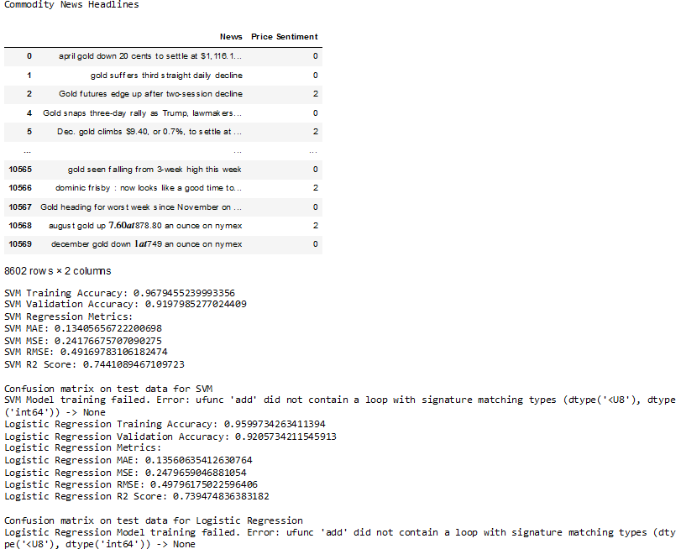

**[SC-2]**

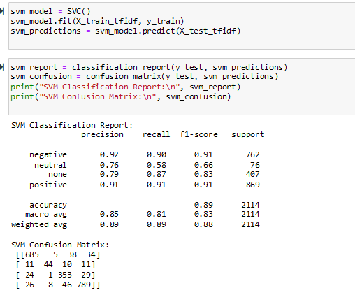

**[SC-3]**

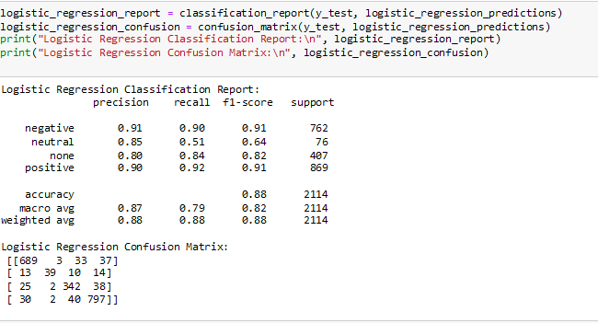

**CODE ::**

# Load packages

import numpy as np

import pandas as pd

from sklearn.feature_extraction.text import TfidfVectorizer

from sklearn.model_selection import train_test_split

from sklearn.metrics import accuracy_score, confusion_matrix

from sklearn.svm import SVC

from sklearn.linear_model import LogisticRegression

from sklearn.metrics import mean_absolute_error, mean_squared_error, r2_score

import re

df = pd.read_csv("gold-dataset-sinha-khandait.csv")

# Let us ignore the news headlines that do not have any price movement information in it

df = df[df["Price Sentiment"] != 'none']

# Convert 'Price Sentiment' to numeric values

df['Price Sentiment'] = pd.Categorical(df['Price Sentiment'])

df['Price Sentiment'] = df['Price Sentiment'].cat.codes

print("Commodity News Headlines")

display(df[["News", "Price Sentiment"]])

# The following piece of code is used to clean the headlines

def cleaner(impure_data):

temp_list = []

for item in impure_data:

# Finding words which start with @

item = re.sub('@\S+', '', item)

# Finding words which start with http

item = re.sub('http\S+\s*', '', item)

# Finding special characters, but not "emoji"

item = re.sub('[%s]' % re.escape("""!"#$%&'()*+,-./:;<=>?@[\]^_`{|}~"""), '', item)

temp_list.append(item)

return temp_list

# Function to calculate accuracy

def calculate_accuracy(model, X, y):

y_pred = model.predict(X)

accuracy = accuracy_score(y, y_pred)

return accuracy

# Function to calculate regression metrics

def calculate_regression_metrics(y_true, y_pred):

mae = mean_absolute_error(y_true, y_pred)

mse = mean_squared_error(y_true, y_pred)

rmse = np.sqrt(mse)

r2 = r2_score(y_true, y_pred)

return mae, mse, rmse, r2

# Updated headline_sentiment function for SVM

def headline_sentiment_svm(df):

headlines = df["News"]

polarity = df["Price Sentiment"].tolist()

# Cleaning headlines i.e. removing @mentions, http(s) links and special characters such as punctuations

clean_headline = cleaner(headlines)

# Initializing tf-idf vectorizer

tf_idfvectorizer = TfidfVectorizer(sublinear_tf=True, use_idf=True)

# Splitting the data into train and test dataset in 70:30 ratio at random

X_train, X_test, y_train, y_test = train_test_split(clean_headline, polarity, test_size=0.3)

train_corpus_tf_idf = tf_idfvectorizer.fit_transform(X_train)

test_corpus_tf_idf = tf_idfvectorizer.transform(X_test)

# Using SVC package to initialize a classifier with Linear kernel and other default parameters

SVM_L = SVC(kernel='linear')

try:

# Fitting the sparse matrix in the classifier with their respective sentiments

SVM_L.fit(train_corpus_tf_idf, y_train)

# Calculate training accuracy

training_accuracy = calculate_accuracy(SVM_L, train_corpus_tf_idf, y_train)

# Calculate validation accuracy

validation_accuracy = calculate_accuracy(SVM_L, test_corpus_tf_idf, y_test)

# This prints accuracy score for the test dataset

print("SVM Training Accuracy:", training_accuracy)

print("SVM Validation Accuracy:", validation_accuracy)

# Predictions for SVM model

y_pred_svm = SVM_L.predict(test_corpus_tf_idf)

# Convert sparse matrices to 1D arrays

y_test_svm_array = np.array(y_test)

y_pred_svm_array = np.array(y_pred_svm)

# Calculate regression metrics for SVM

mae_svm, mse_svm, rmse_svm, r2_svm = calculate_regression_metrics(y_test_svm_array, y_pred_svm_array)

print("SVM Regression Metrics:")

print("SVM MAE:", mae_svm)

print("SVM MSE:", mse_svm)

print("SVM RMSE:", rmse_svm)

print("SVM R2 Score:", r2_svm)

# This prints confusion matrix for the test dataset

labels_svm = np.unique(y_test)

m_svm = confusion_matrix(y_test_svm_array, SVM_L.predict(test_corpus_tf_idf), labels=labels_svm)

print("\nConfusion matrix on test data for SVM")

cm_svm = pd.DataFrame(m_svm, index=labels_svm, columns=labels_svm)

cm_svm.index = "Actual: " + cm_svm.index

cm_svm.columns = "Predicted: " + cm_svm.columns

display(cm_svm)

# Saving the data into a csv file in the current folder

temp_df_svm = pd.DataFrame()

temp_df_svm["News"] = X_test

temp_df_svm["Actual Price Sentiment"] = y_test_svm_array

temp_df_svm["Predicted Sentiment"] = SVM_L.predict(test_corpus_tf_idf)

temp_df_svm.to_csv("predicted_svm.csv")

print('Predictions on Test Data for SVM are as follows:')

display(temp_df_svm)

except Exception as e:

print(f"SVM Model training failed. Error: {e}")

return tf_idfvectorizer, SVM_L

# Updated headline_sentiment function for Logistic Regression

def headline_sentiment_logistic(df):

headlines = df["News"]

polarity = df["Price Sentiment"].tolist()

# Cleaning headlines i.e. removing @mentions, http(s) links and special characters such as punctuations

clean_headline = cleaner(headlines)

# Initializing tf-idf vectorizer

tf_idfvectorizer = TfidfVectorizer(sublinear_tf=True, use_idf=True)

# Splitting the data into train and test dataset in 70:30 ratio at random

X_train, X_test, y_train, y_test = train_test_split(clean_headline, polarity, test_size=0.3)

train_corpus_tf_idf = tf_idfvectorizer.fit_transform(X_train)

test_corpus_tf_idf = tf_idfvectorizer.transform(X_test)

# Initializing Logistic Regression model

log_reg = LogisticRegression()

try:

# Fitting the sparse matrix in the classifier with their respective sentiments

log_reg.fit(train_corpus_tf_idf, y_train)

# Calculate training accuracy

training_accuracy_log = calculate_accuracy(log_reg, train_corpus_tf_idf, y_train)

# Calculate validation accuracy

validation_accuracy_log = calculate_accuracy(log_reg, test_corpus_tf_idf, y_test)

# This prints accuracy score for the test dataset

print("Logistic Regression Training Accuracy:", training_accuracy_log)

print("Logistic Regression Validation Accuracy:", validation_accuracy_log)

# Predictions for Logistic Regression model

y_pred_log = log_reg.predict(test_corpus_tf_idf)

# Convert sparse matrices to 1D arrays

y_test_log_array = np.array(y_test)

y_pred_log_array = np.array(y_pred_log)

# Calculate regression metrics for Logistic Regression

mae_log, mse_log, rmse_log, r2_log = calculate_regression_metrics(y_test_log_array, y_pred_log_array)

print("Logistic Regression Metrics:")

print("Logistic Regression MAE:", mae_log)

print("Logistic Regression MSE:", mse_log)

print("Logistic Regression RMSE:", rmse_log)

print("Logistic Regression R2 Score:", r2_log)

# This prints confusion matrix for the test dataset

labels_log = np.unique(y_test)

m_log = confusion_matrix(y_test_log_array, log_reg.predict(test_corpus_tf_idf), labels=labels_log)

print("\nConfusion matrix on test data for Logistic Regression")

cm_log = pd.DataFrame(m_log, index=labels_log, columns=labels_log)

cm_log.index = "Actual: " + cm_log.index

cm_log.columns = "Predicted: " + cm_log.columns

display(cm_log)

# Saving the data into a csv file in the current folder

temp_df_log = pd.DataFrame()

temp_df_log["News"] = X_test

temp_df_log["Actual Price Sentiment"] = y_test_log_array

temp_df_log["Predicted Sentiment"] = log_reg.predict(test_corpus_tf_idf)

temp_df_log.to_csv("predicted_logistic.csv")

print('Predictions on Test Data for Logistic Regression are as follows:')

display(temp_df_log)

except Exception as e:

print(f"Logistic Regression Model training failed. Error: {e}")

return tf_idfvectorizer, log_reg

# Testing the SVM model

vectorizer_svm, model_svm = headline_sentiment_svm(df)

# Testing the Logistic Regression model

vectorizer_logistic, model_logistic = headline_sentiment_logistic(df)